

**Session 3**

**1/9/2022**

**Task 1:**

* **What is miniconda & what is the difference between it an anaconda ?**

Miniconda is a free minimal installer for conda. It is a small, bootstrap version of Anaconda that includes only conda, Python, the packages they depend on, and a small number of other useful packages, including pip, zlib and a few others.

There are essentially two main differences:

1. **Number of packages:** Anaconda comes with over 150 data science packages, whereas miniconda comes with only a handful.
2. **Interface:** Anaconda has a graphical user interface (GUI) called the Navigator, while miniconda has a command-line interface.

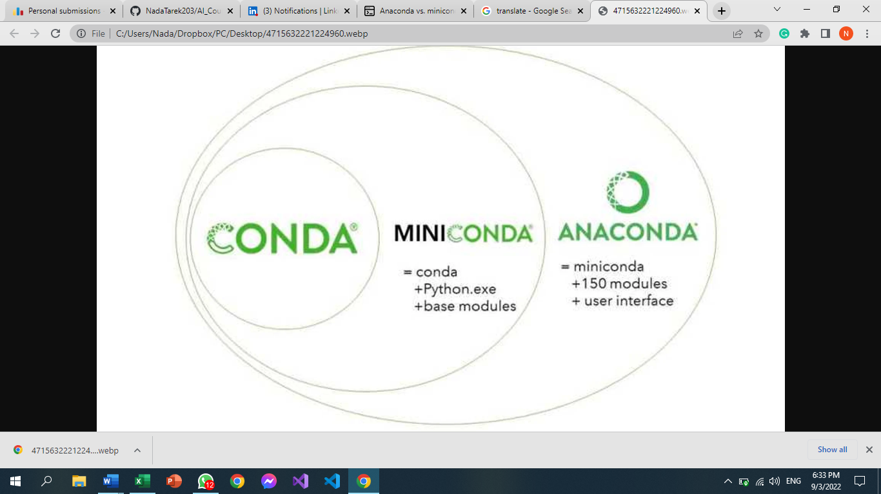

**Task 2:**

* **Not clean code and someone who optimized it into a clean code**
  1. **Meaningful names**

Bad: var d; // elapsed time in days

Good: var elapsedTimeInDays;

var daysSinceCreation;

var daysSinceModification;

* 1. **Avoid Disinformation**

Bad: var accountList = [];

Good: var accounts = []

* 1. **Use Searchable Names**

Bad: if (student.classes.length < 7) {

// Do something}

**Good:** if (student.classes.length < MAX_CLASSES_PER_STUDENT) {

// Do something}

**Task 3:**

* What is the framework and its benefits ?

In software engineering, frameworks are tools that help professionals build apps, websites, and digital systems. Since they function as blueprints for these different projects, frameworks can help programmers, developers and coders conduct tasks more effectively. If you're interested in a career in software development, you may benefit from having a better understanding of frameworks

A framework provides a foundation for developing software applications, Software engineers and developers use a framework as a template in order to create websites and applications. Professionals do this by adding code to a framework, then personalizing it for their specific purpose. A framework can combine multiple resources, such as an image or document file, to create a package unique to a project. Even after an application is complete, coders can revise the framework of an application to add new features or edit existing components.

Its benefits:

* Saving software professionals time and energy
* Providing a basic outline for coders to follow
* Allowing coders to focus on tasks more specific to their project
* Creating clean and adaptable code
* Reducing costs by shortening the amount of time a professional spends programming the application

**Task 4:**

* What is the most popular in pc and smartphones?
  + In pc:
    1. Intel Core i19
    2. Intel Core i15
    3. AMD Ryzen 7 5800X3D
    4. AMD Ryzen 9 5900X
    5. AMD Ryzen 7 5800X
  + In smartphones:
    1. Apple A14 Bionic
    2. Snapdragon 888
    3. Exynos 2100
    4. Apple A13 Bionic
    5. Kirin 9000

**Task 5:**

**Task 6:**

* **what is hashtables ? why we use hash tables in unordered list**?

A **hash table** is a type of data structure that stores key-value pairs. The key is sent to a hash function that performs arithmetic operations on it. The result (commonly called the hash value or hash) is the index of the key-value pair in the hash table.

**Task 7:**

* **how to print the error type for the user in try catch**?

try:

variable = None

print(variable[0])

except Exception as e:

print(e)

print('Am I executed?')

References:

1. <https://www.educative.io/answers/anaconda-vs-miniconda> [htt ps://www.techopedia.com/definition/27857/thread-operating-systems](https://www.techopedia.com/definition/27857/thread-operating-systems)